

Project Proposal

LF Hospital Management System

60-334-30

Submitted by Larsen Friis

104127870

Submitted for Abedalrhman Alkhateeb

July 23, 2017

**Section 1: Topic, scope, and use cases**

The topic I have selected for my final project will be a Hospital management system. This system will be designed for a fully functional hospital that will have 4 levels of privileges:

* Admin
* Doctor
* Nurse
* Receptionist/Secretary

1. User will login in to system, and depending on that login will grant them different access
2. The receptionist has the ability to check which rooms are occupied or are open for patients
3. Receptionists will be able to book appointments and surgeries depending on the availability of the doctor (scheduling)
4. Receptionist also to update demographic information of patients
   1. Information will be forwarded to patient record
5. Nurses will fulfil patient care needs
   1. Also will have the ability to discharge patients along with surgery follow up
6. Doctors will be the only ones allowed the prescribe medications for patients and are able to execute 4(a)
7. The admin will have full access to the system and have the ability to read and write data

A close up of a map

Description generated with high confidence

**Section 2: User levels (privileges)**

1. **Admin** will have access to alter, read, and write data in the entire system. This will be the highest level of access
2. **Doctor** will have access to read and write in patient files and have higher accessibility access to the system. They will be the only user to have permissions to grant prescribe medication to patients. Also will have the ability to confirm that surgeries/check ups have been completed following with the ability to discharge.
3. **Nurse** will have similar access to the Doctor except not having the ability to prescribe medication and the are required to fulfill patient everyday care needs.
4. **Receptionist/Secretary** will have access to modify client/patient demographic information, book and monitor rooms, send notifications to Doctors and Nurses.

**Section 3: Queries**

1. Login page will check user level corresponding to user privileges (1-4)
2. Log out page to have the ability to switch users without reloading page4
3. Search which rooms are available
4. View schedule of doctors, nurses
5. View scheduling of surgeries
6. Overview all appointments
7. Add new appointments, surgeries and appointments S
8. Add patient record to system
9. Update patient demographic system
10. Delete patient records
11. Search patient records
12. Add specific data entries (notes, prescriptions etc.)
13. Add reminders to patients
14. Edit patient records
15. Assign doctor and nurse to specific patient

**Section 4a: Website Design**

**Website Logo:**



**Login Page:**

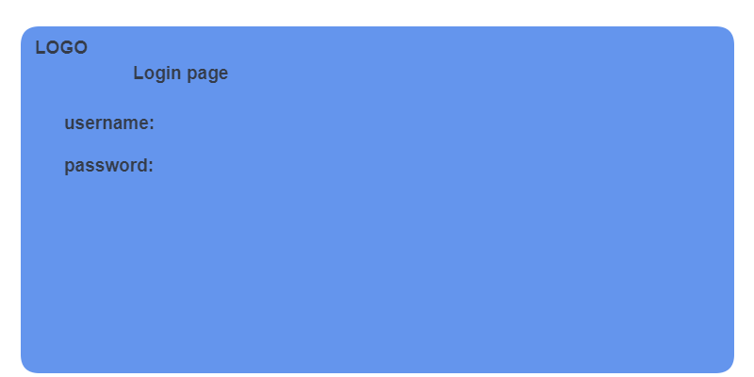

**Schedule Page:**

**A screenshot of a cell phone

Description generated with high confidence**

**Patient Record:**

**A screenshot of a cell phone

Description generated with very high confidence**

**Patient Rooms:**

**A screenshot of a cell phone

Description generated with very high confidence**

**Mobile View:**

**A screenshot of a cell phone

Description generated with high confidence**

**Section 4b: Database Design**

**User_profiles:**

|  |  |  |
| --- | --- | --- |
| **User_code** | **User_description** | **Created_date** |
| **INT(1)** | VARCHAR(10) | CURRENT_TIMESTAMP |

* Many-to-many relationship across system

**Patient_profile:**

|  |  |  |  |  |
| --- | --- | --- | --- | --- |
| **Patient_id** | **Fname** | **Lname** | **Sex** | **Dob** |
| **INT(2)** | **VARCHAR(20)** | VARCHAR(20) | INT(3) | VARCHAR(10) |

**Patient_record:**

|  |  |  |  |  |
| --- | --- | --- | --- | --- |
| **User_code** | **Patient_id** | **Room_id** | **Date_emitted** | **Date_dischargred** |
| **INT(1)** | **INT(2)** | INT(3) | CURRENT_TIMESTAMP | CURRENT_TIMESTAMP |

**Precription_record:**

|  |  |  |  |
| --- | --- | --- | --- |
| **User_code** | **Patient_id** | **Prescription_id** | **Time_of_sub** |
| **INT(1)** | **INT(2)** | INT(2) | CURRENT_TIMESTAMP |

* Dependent on the user_code privileges

**Section 5: Data Analysis**

This hospital management system will generate reports semi-annually:

* Number of patients in the last 6 months
* Surgeries completed
* Prescriptions written
* Average length of patient stay
* Total appointments per day

All these factors will help generate reports needed to keep providing services at an optimal level

**Section 6: System administration, testing, and maintenance plan**

I will follow out testing by using numerous test cases, different naming conventions and different combinations to see where the system has faults and improve it to ensure it operates a flawlessly. By these test cases, I can ensure there is no injections, not breeches of security due to patient confidentiality, and constantly optimizing the system.

**Directory Structure:**

LFHMS ->

* Images: logo
* HTML: login, index, schedule, patient record
* CSS: styling for website
* JS: functions used in the system